Project Setup Guide: **FoodPicky-CICD**

**Follow the steps below to run the project on your local machine.**

Prerequisites:

- XAMPP installed

- Git installed

**Steps to Set Up the Project (Short Version)**  
----------------------------------------------------------------------------------------------------------------

1. Open CMD and run:

cd C:\xampp\htdocs

git clone <https://github.com/dipak-mohite/FoodPicky-CICD>

2. Start XAMPP:

- Start Apache and MySQL services

3. Setup Database:

- Go to: http://localhost/phpMyAdmin

- Click "New", name the database: foodpicky_db, then click "Create"

- Go to the "Import" tab

- Select: C:\xampp\htdocs\FoodPicky-CICD\Database\foodpicky_db.sql

- Click "Go" to import

4. Run Project:

- Home Page: <http://localhost/FoodPicky-CICD/>

- Admin Page: <http://localhost/FoodPicky-CICD/admin/>

5. Admin Panel:

- Open: http://localhost/FoodPicky-CICD/admin/

- Default Login:

Username: Admin

Password: 1234

6. Create New Accounts:

- Signup as a user from the frontend

- To register as admin, use this code during signup: QX5ZMN

The project is now ready and running on your local machine.

**Steps to Set Up the Project (Detailed Version)**  
----------------------------------------------------------------------------------------------------------------

**Step 1: Clone the Repository**

1. Open Command Prompt (CMD).

2. Navigate to the XAMPP htdocs directory:

cd C:\xampp\htdocs

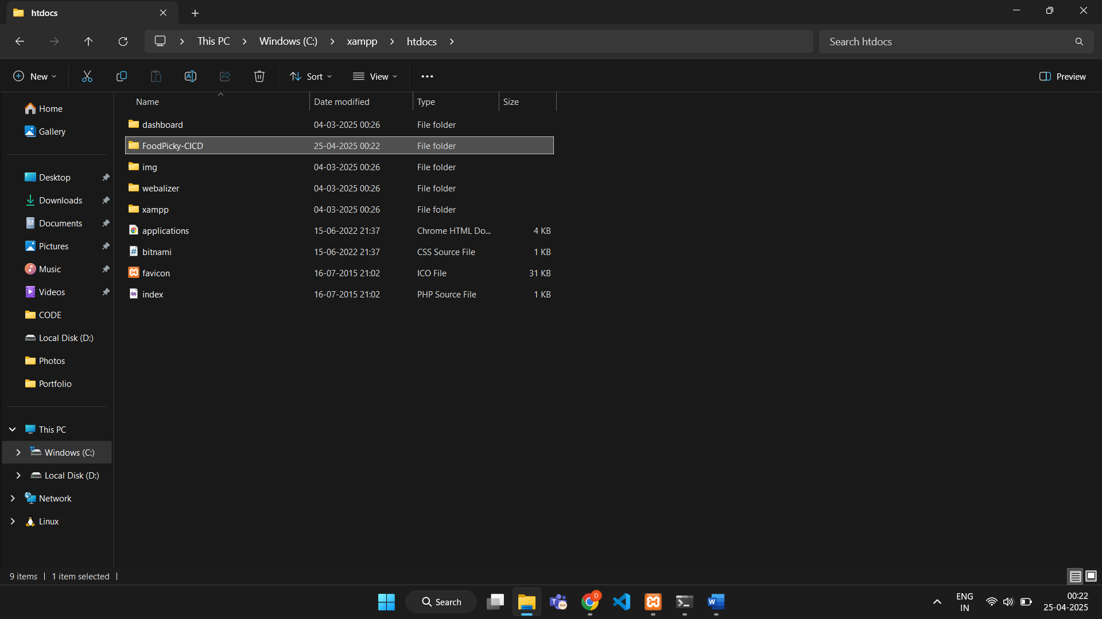

3. Run the following command:

git clone <https://github.com/dipak-mohite/FoodPicky-CICD>

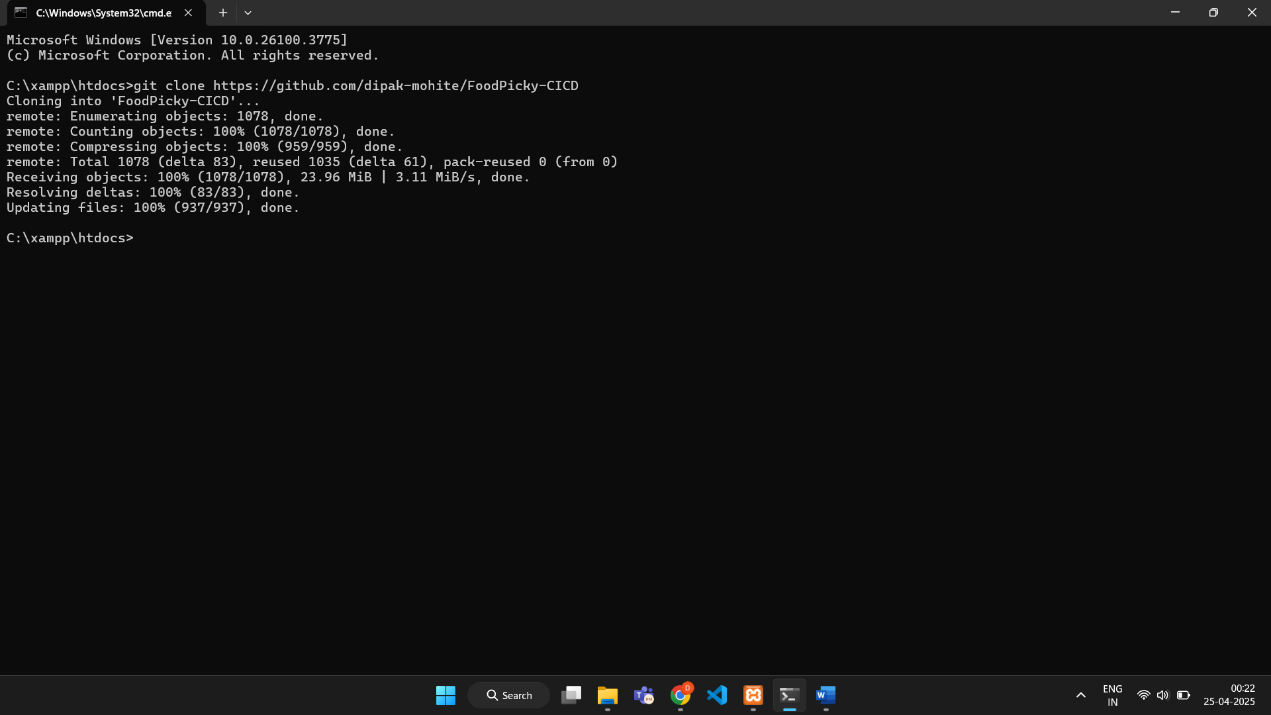

**Step 2: Open XAMPP Control Panel**

Start these services: Apache and MySQL

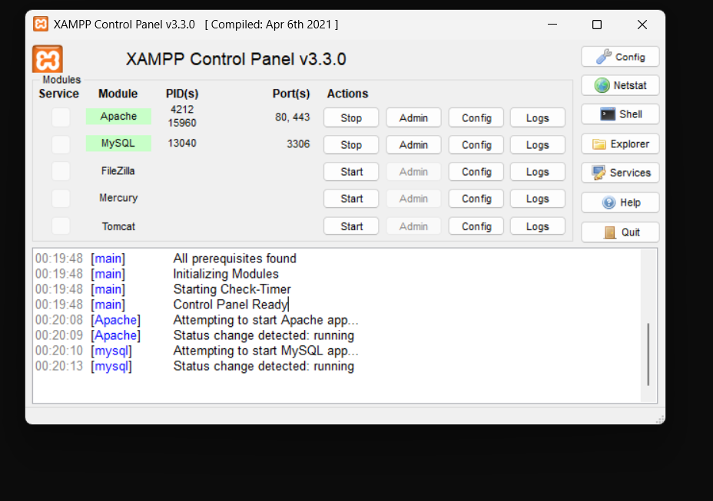

**Step 3: Import the Database**

1. Open Chrome and go to:

http://localhost/phpMyAdmin

2. Click on "New" in the left sidebar.

3. Enter database name: foodpicky_db

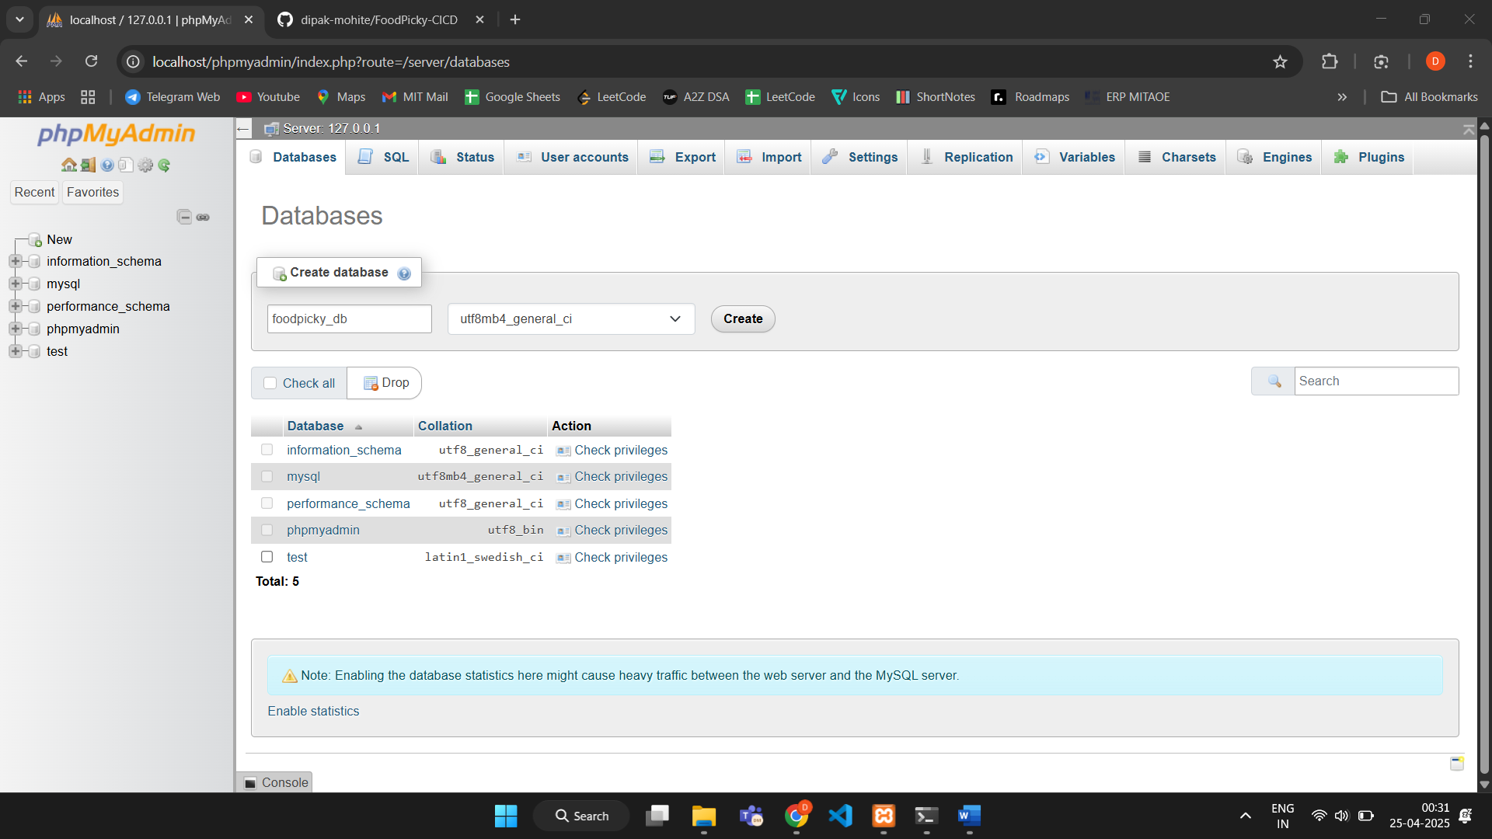

4. Click "Create".

5. Go to the "Import" tab.

6. Click "Choose File" and select:

C:\xampp\htdocs\FoodPicky-CICD\Database\foodpicky_db.sql

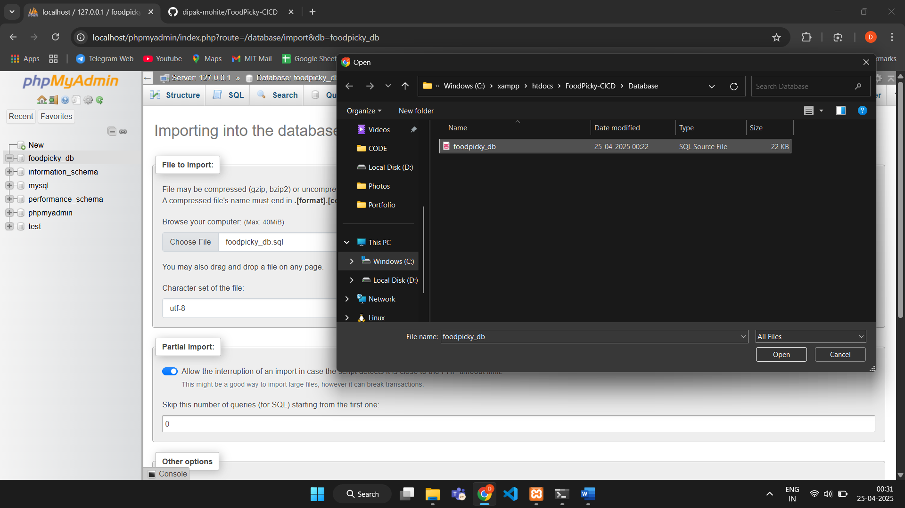

7. Scroll down and click "Go" to import.

**Step 4: Run the Project**

1. Open Chrome and go to:

http://localhost/FoodPicky-CICD/

2. You should now see the homepage of the FoodPicky project.

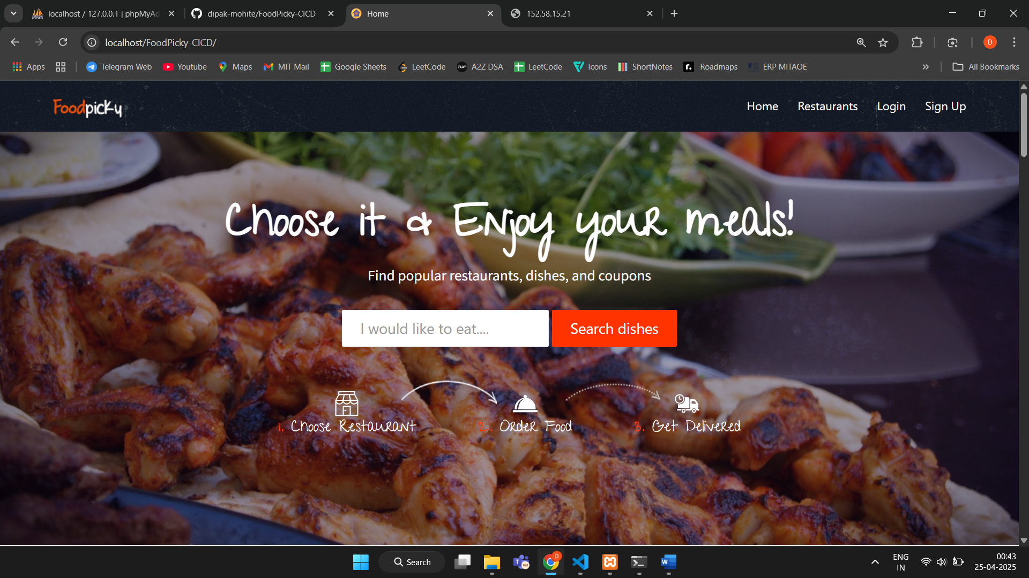

Admin Dashboard Login:

URL:

<http://localhost/FoodPicky-CICD/admin/>

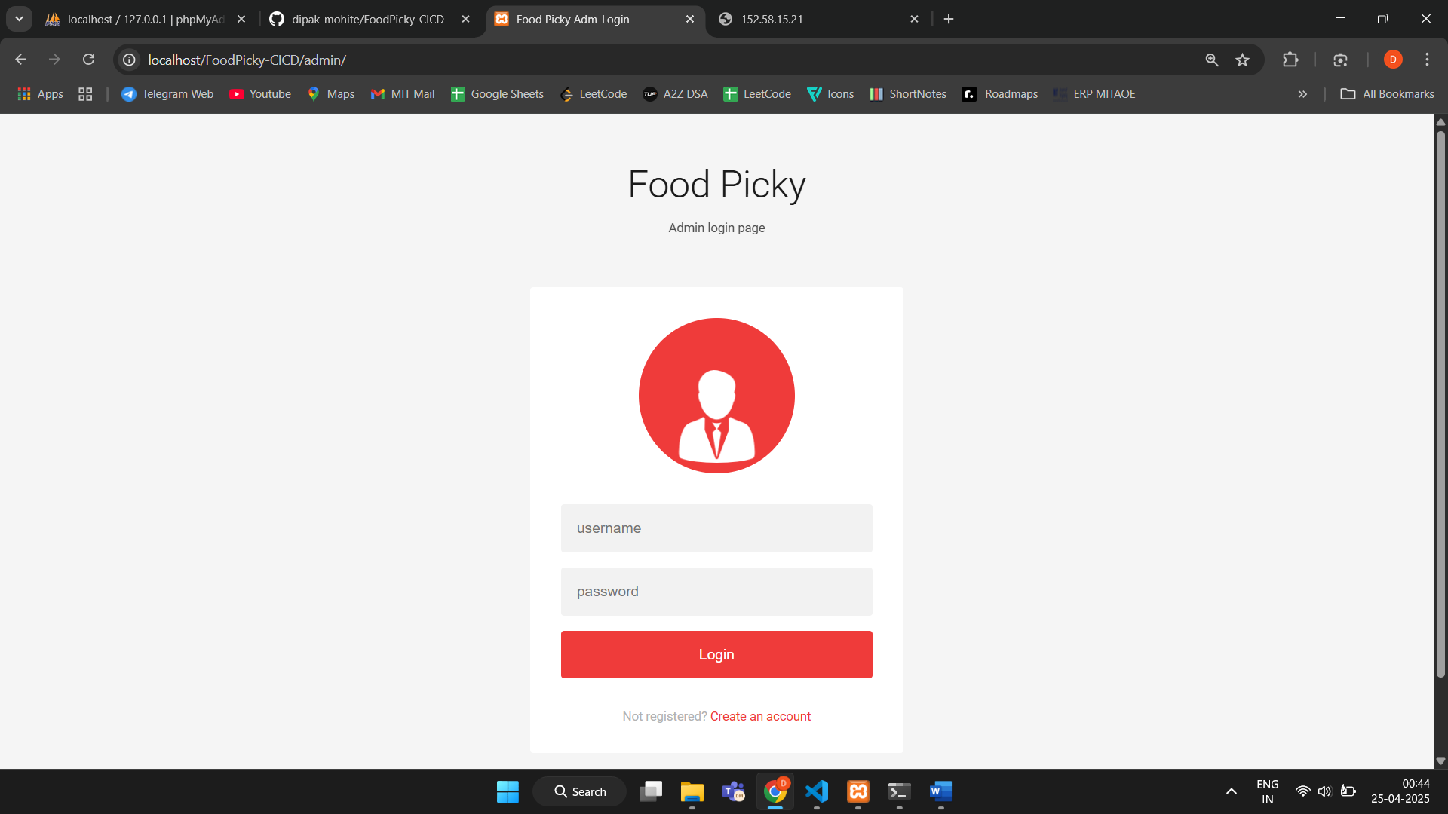

Admin Credentials-

Username: Admin

Password: 1234

- You can create your own User and Admin Accounts

- To create an admin account, use the special admin code:

Admin Code: QX5ZMN

(Use this code during the signup process to register as an admin)

Done! The project is now running on your local machine.